2024 JC1 Promo Exam Paper 1 (Theory) – Suggested Solutions
1(a) | 1. The search will at first encompass the entire array from index 0 to 7  2. The middle index is calculated as (0 + 7) // 2 = 3, where 51 was found. Since 51 is bigger than the key, the search should continue in the left-half. The search region is now confined from index 0 to 2.  3. The new middle index is calculated as (0 + 2) // 2 = 1, where 37 was found. Since 37 is smaller than the key, the search should continue in the right-half. The search region is now confined from index 2 to 2.  4. At index 2, 42 was found, which matches the key. The search stops here. | 1m: Initialising and use of indices  1m: Calculating middle index  1m: Eliminating one half
(b) | For this specific case, both algorithms appear to take the same number of steps to find this key 42 due to the specific position of the key in the array. But this does not mean they are equally efficient in general cases with large arrays.  Linear search has a time complexity of O(n), eliminating the search space by 1 for each step taken to find the key.  Binary search has a time complexity of O(lg n) which is much faster for large sorted arrays, because it reduces the search space by half with each step/iteration. | 1m: Same for particular context  1m: O(n) for linear  1m: O(lg n) for binary  1m: reduces the search by half

2(a) | The unsorted array is recursively split into two until they are single-element arrays, and then recursively recombining them, sorting the array in the process by comparing the first elements of each sub array.  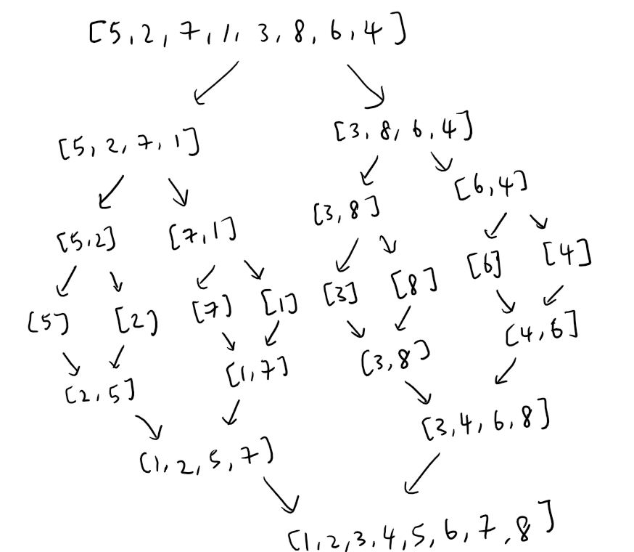 | 1m: split  1m: combining  Diagram  1m: show splitting into halves until single element  1m: recombining them into a sorted array
(b) | 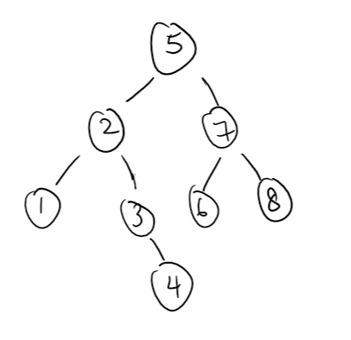 | 1m: root node is 5  1m: left subtree correct  1m: right subtree correct

3(a) | Chocolate colour D2:69:1E to binary:  1101 0010 0110 1001 0001 1110 | 1m: Concept/Calc  1m: Final ans
(b) | - Hexadecimal numbers are of base 16, related to base 2 in digital data.  - This aligns well with binary/digital data in computer systems with 4 binary digits forming 1 hexadecimal digit, making it easier to convert to binary values (digital data) directly, Decimal representation requires more complex conversions to digital data.  - Hexadecimal can be easier/more intuitive to read than large decimal numbers, improving clarity when examining digital data for debugging. For instance, in Q3a, it is difficult to segment the denary colour (3 050 327) into the separate RGB components as opposed to the hexadecimal form. | 1m  Alignment to digital data (binary)  1m  Intuitive/more useful in digital context

4(a) | A suitable composite PK: {CustomerID, ProductID, Date} | 1 mark
4(b) | 1. The value of a PK can be used to uniquely identify a particular record in a table.  2. The records in a table are sorted by the PK for easy searching and retrieval. | 1 mark each

5(a) | A: Switch B: Router | 1 mark each
5(b) | Differences between a switch and a router (any 2 of the followings:  1. Router:  - Function: A router connects multiple networks and directs data between them. It determines the best path for data to travel from one network to another.  - IP Addressing: Routers use IP addresses to forward data to the correct destination across networks.  - Connection: It connects different networks (e.g., local networks to the internet or different subnetworks).  2. Switch:  - Function: A switch connects multiple devices within the same network (e.g., computers, printers). It forwards data to the correct device based on its hardware (MAC) address.  - MAC Addressing: Switches use MAC addresses to forward data between devices in a local area network (LAN).  - Connection: Primarily used to connect devices like PCs, printers, and servers within the same network.  Key Differences:  - Purpose: Routers connect different networks, while switches connect devices within the same network.  - Addressing: Routers use IP addresses, switches use MAC addresses.  - Functionality: Routers direct traffic between networks, while switches manage traffic between devices within a single network. | 1 mark each

